***AUGUST 2019 LIVE JAZZ***

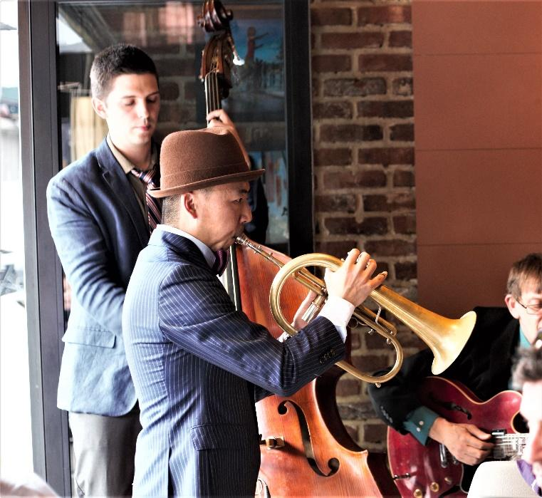

4nd*: 1 pm - 4 pm: EMANUELE TOZZI –TRIO- (piano)*

11th: *1 pm - 4 pm: DAN WEISSLBERG (Trio American Jazz)*

[*https://uk.linkedin.com/in/dan-weisselberg-0b56bb18*](https://uk.linkedin.com/in/dan-weisselberg-0b56bb18)

18th*: 1 pm - 4 pm:* CHARLIE AND FRIENDS *(Gipsy Jazz)*

*6.30 pm – 9.30 pm: LIZZIE THOMAS* *(Live Concert)*

28th: *1 pm - 4 pm:* ANDREA BALDUCCI (Pianoforte, Voice )