SEPTEMBER 2019 LIVE JAZZ calendar
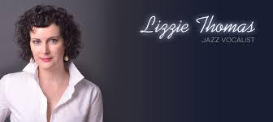

1st SUNDAY BRUNCH: 1pm - 4pm: SALVO LOSAPPIO (Sax Jazz)

8th SUNDAY BRUNCH: 1pm - 4pm: ANDREA BALDUCCI (Pianoforte, Voice)

15th SUNDAY BRUNCH 1pm - 4pm: DAVID MCKAY: ”The D.M. Brunch Special”

22nd SUNDAY BRUNCH 1pm - 4pm: RYO SASAKY (Trio American Jazz)
22nd SUNDAY DINNER 6.30pm – 9.30pm: LIZZIE THOMAS (Live Concert)

29th SUNDAY BRUNCH 1pm - 4pm: EMANUELE TOZZI (Trio, Piano)

